Fall Prevention
NUR 572 Teaching Project
Roman Batyuk
SUNY Polytechnic Institute

Fall Prevention Teaching Project NUR 572
Introduction
As nursing providers we are frequently asked to care for those injured or ill, however an integral part of that care involves prevention in the form of teaching. Daniel Dennis, a fellow nurse practitioner student, and I performed a community assessment on the Village of Camillus and found the residents were in need of such teaching. A primary finding of ours was the frequent need for emergency medical services within a housing structure for elderly residents who experienced frequent falls. Emergency personnel from the responding agency informed us that most 911 calls to that facility occurred at night. The resident(s) would then require assistance with standing back up or transporting them to the hospital after injuries were sustained.
Although the reasons for falls varied a community diagnosis of risk to fall in the elderly population related to an unsafe home environment as evidenced by frequent 911 calls requiring assistance after falling at home, was determined. Understanding that injuries sustained at an older age can result in significant loss of function, independence, and even death, our goal was to educate these individuals at highest risk on fall prevention.
Identification of group and assessment of learners
The residents identified in need of fall prevention teaching were found within a senior housing complex in Camillus N.Y. called Fairmount Gardens. Individuals within this complex originated from various counties within New York State with some as far as Oswego and Cayuga county. Six residents were in attendance to our fall prevention teaching, all of which wore corrective lenses and four of whom required an assistive device to ambulate. Although our interaction with the residents was brief and did not include such things as a physical assessment, they all appeared to be in good health with ages ranging from 67 to 95 years old. The residents were able to inform us that in order to live within the complex they must be able to provide total care for themselves as it is not an assisted living facility nor does it provide medical support of any kind. Property manager, Gwen Williams reinforced this and informed us that the owners, National Church Residences, do not provide any service other than property management and monthly rent is determined on a resident-to-resident basis.
Prior to the beginning of our presentation we had the opportunity to discuss the backgrounds of the residents in attendance and learned the education levels were from high school graduates to those with advanced degrees. Based on our conversations with them it was evident they were able retain new information as they were able to remember our names.
The developmental level of these residents, according to Barnstable (2014) is labeled as ego integrity versus despair based on Erikson’s theory of psychosocial development (p. 199). This particular stage is when older adults deal with the “reality of aging” with death being a part of that (Barnstable, 2014, p. 199). It includes changes such as; retirement, illness or death of family and friends, relocation of children, family, and sometimes moving to unfamiliar environments (Barnstable, 2014, p. 200).
Due to the amount of changes encountered within this particular stage; depression, grief, loneliness, and isolation are major barriers towards further development (Barnstable, 2014, p. 201). For this reason it is important to promote independence, social acceptability, adequacy of personal resources, coping mechanisms, and having a meaning of life (Barnstable, 2014, p. 202). When these traits are achieved the individuals ability related to motivation and learning are significantly higher (Barnstable, 2014, p. 201). In order to facilitate the learning process, teaching strategies must be specifically focused on this particular developmental stage. This can be accomplished by establishing a therapeutic relationship through things such as reminiscing (Barnstable, 2014, p. 201). Taking that into account, our approach with the residents was to talk about their backgrounds and lives, after which they opened up and were actively participating during the entire presentation.
Learner’s needs based on risk assessment
Based on our community assessment findings we were able establish a need for education regarding fall prevention of the elderly. This information was obtained after talking to WAVES Ambulance medical personnel who informed us that the senior complex had a high number of 911 calls following falls. Although the reasons for falls were not available from the ambulance agency, we were able to determine that they were taking place within the home and primarily during the night. Utilizing information obtained via research we were able to focus our attention on numerous reasons that elderly individuals may fall within their home such as pets, clutter, medication use, poor lighting, and others. Furthermore once reasons of falling are identified, the residents would then be able to implement fall reduction techniques.
Identification of the project goals
As with most teaching we began by asking the residents that have previously fallen the reasons or conditions that led to their fall(s). Our primary goal was then to have them identify the top reasons that influenced falls in the elderly at home. A secondary goal was to verbalize actions that can be taken to reduce the risk of falls within their homes. The tertiary goal was having the residents verbalize exercises that are known to reduce fall risk.
List of behavior objectives (outcome criteria)
The participant will:
- Be able to identify interventions related to pets in the home that will reduce their risk to fall.
- Be able to identify the location where the most frequent number of falls occur.
- Be able to identify three items in the home that increase the risk of falls.
- Be able to identify the frequency of eye appointments recommended for vision checks to reduce the fall risk.
- Be able to identify three medication types that are associated with higher fall rates.
- Be able to identify to exercises that are beneficial in assisting in fall reduction.
- Be able to identify the minimum number of balance and exercise needed in one week.
- Be able to identify the footwear that is most appropriate to reduce falls.
Description of the teaching environment
The location of our teaching took place within the senior housing complex in a common area the residents refer to as the rec-room. The room was located on the first floor in the middle of the facility and was able to accommodate up to 40 people with clear access for those with assistance devices such as walkers. Natural lighting was abundant from the wall of windows and sliding glass doors however there was a plethora of additional overhead lighting available. The room was decorated appropriately and tactfully with comfortable seating and tables spread out far enough to allow ample room for ambulation. In addition the room had a small kitchen off of it and an outdoor patio with additional sitting arrangements. The room itself was warm, clean, and free of odors and allowed for a great teaching environment.
Outline of Content to be covered in the teaching session
- Falls:
  - Most common location of falls
  - Morbidity and mortality of falls
- Home Safety
  - Physical layout:
    - Obstacles on floor
    - Throw rugs
    - Clutter
    - Cords
  - Stairs/steps
    - Clutter (remove)
    - Broken or uneven (fix them)
    - Lighting (ensure adequate)
    - Carpet (secured)
    - Handrails (secured/available)
  - Kitchen
    - Keep frequently used items in easy to reach location
    - Proper step stool when needed to reach high
  - Bathroom
    - Keep floor dry
    - Grab bars
  - Bedroom
    - Lights in easy to reach locations
    - Keep walkway to bathroom and hallway clear
- Pets
  - Keep properly caged when using assistive devices
  - Secure with gates
- Footwear
  - Should be worn inside and outside
  - Rubber soled
  - Fit properly
- Medications associated with falls
  - High blood pressure
  - Cardiac
  - Pain
- Vitamin D associated with decreased falls
- Vision – Annual exams
- Exercise
  - Leg raises
  - Arm curls
  - Resistance bands
  - Front arm raises
  - Chair dip
  - Toe stand
  - Tai Chi
- Questions
Literature Review
A literature review was conducted to determine fall rates among the elderly population as well as investigating the types of methods utilized to reduce those rates. Kelsey, Proctor-Gray, Hannan & Li (2012) conducted a prospective cohort study that included 765 women and men within a particular community (p. 2149). This study found that over 4.3 years a total of 1737 falls occurred with the more taking place indoors and about 10% of them all resulting in serious injury (Kelsey, et. al., 2012, p. 2149). The findings of this study show a strong need for programs aimed at fall prevention that are tailored to specific locations and characteristics.
Lynn Beattie (2014) wrote an article detailing risk assessment and methods to reduce the risk to fall in simple yet proven ways. Similar to other data found, she outlines that “one in 3 older Americans fall each year” and “falls are the leading cause of both fatal and nonfatal injuries” in those 65 years or older (Beattie, 2014, p. 31). Given this knowledge and using the research available she concludes that many falls are preventable through relatively simple measures such as risk identification and specific intervention (Beattie, 2014, p. 31). One method is through tai chi, a program developed to improve balance and proven to reduce the number of falls and the risk to fall among older adults.
Campbell & Robertson (2013) further emphasize the need for identification of contributing factors of falls in the elderly population. They identified common factors leading to falls being “poor strength and balance, psychotropic drugs, low blood pressures, multifocal glasses, and household clutter” (Campbell & Robertson, 2013, p. 281). Additionally they discuss the effectiveness that any prevention techniques can only be successful if the older person is willing, able to participate, and can adhere to it (Campbell & Robertson, 2013, p. 281). Randomized controlled trials showed evidence that the interventions do not need to be multifactorial and single interventions were just as effective in the reduction of falls within the elderly population (Campbell & Robertson, 2013, p. 281).
Supporting the need for multifactorial fall reduction interventions, Dr. Lesley Day (2013) discusses the misconception within the literature that single interventions are just as effective. Multifactorial interventions frequently include exercise, strength, and balance improvement but also take into consideration things such as the individual’s health history, medications, and environment (Day, 2013, p. 284). She suggests that utilizing a multifactorial approach will have strong and broader effects in the reduction of falls within the elderly population.
Finally Danielle Knudson (2013) underlines similar findings of other studies of one in three adults over the age of 65 will fall each year (p. 8). She makes a clear point of the methods and areas to focus on when attempting to decrease the risk to fall within that population of individuals which includes utilizing existing programs such as FIRST (Fall Intervention-Reaching Seniors Together) (Knudson, 2013, p. 8). Among them are home safety and modifications which includes checklists and suggestions on making the home safer, medication management to identify and modify those linked to falls, and physical activity and mobility to improve balance (Knudson, 2013, p. 8).
Teaching methods and materials
The primary teaching method was via power point presentation (attached file) that was supplemented by pamphlets as shown below.

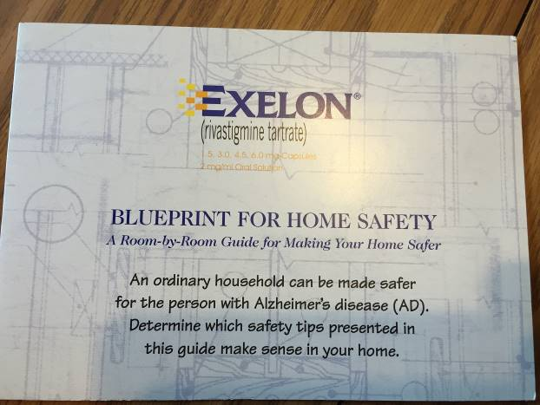

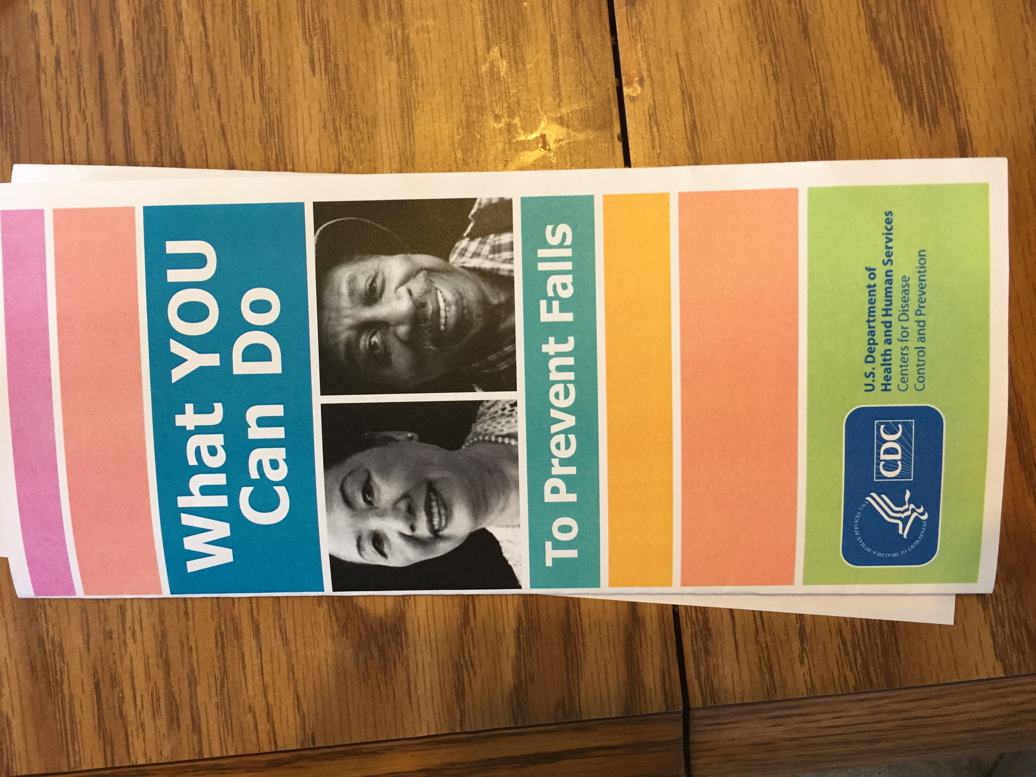

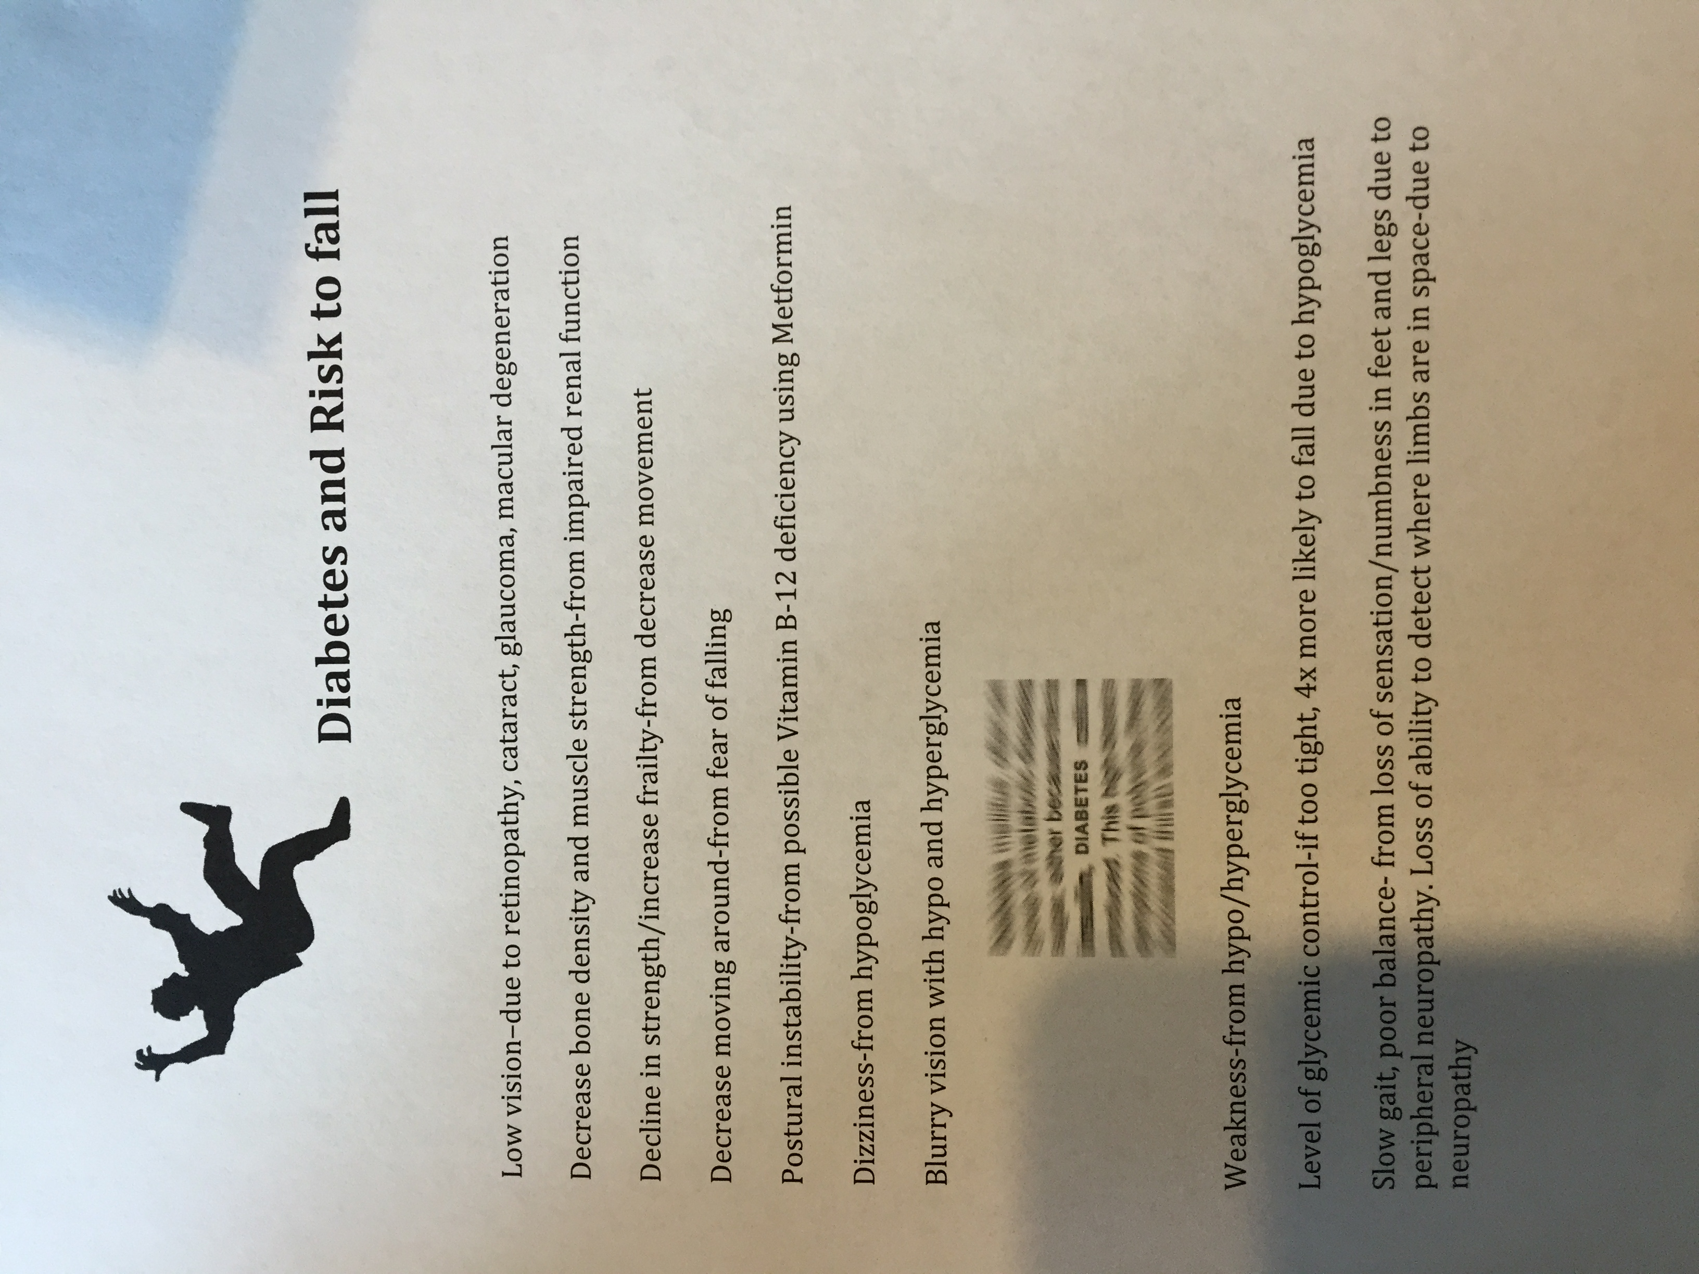

Teaching Evaluation
My role in this project was to assist in finding current research information related to falls and fall prevention within the elderly population. Dan and I both contributed equally to this portion of the project while I formed the questions based on the review of research and Dan prepared the PowerPoint presentation. There were numerous changes/suggestions I gave Dan for the PowerPoint that he then made and we both reviewed it to ensure appropriate content was included. The presentation itself was split so that both Dan and I both had an equal opportunity to speak and ask questions.
Our ability to teach and the residents ability to learn was evaluated utilizing numerous verbal/visual questions at the end of the powerpoint for which all those in attendance were able to answer 100% correctly. Throughout the presentation all residents were engaged and able to verbally participate, resulting in 100% objective achievement for all residents. The evaluation tool is located towards the end of the PowerPoint presentation in the form of questions. The residents did state they would have had more fun and been engaged more if snacks or prizes were available which would be an appropriate recommendation for future teaching.

References
Bastable, S. (2014). Nurse as Educator. Burlington, MA: Jones & Bartlett Learning.

Beattie, L. (2014). Effective fall-prevention demands a community approach. Journal of Geriatric Physical Therapy, 37(1), 31-34.

Campbell, J. A., & Robertson, C. M. (2013). Fall prevention: Single or multiple interventions? Single interventions for fall prevention. American Journal of Geriatrics Society, 61, 281-287.

Day, L. M. (2013). Fall prevention for community-dwelling older people should primarily target a multifactorial intervention rather than exercise as a single intervention. American Journal of Geriatrics Society, 61(2), 284-285.

Kelsey, J. L., Procter-Gray, E., Hannan, M. T., & Li, W. (2012). Heterogeneity of falls among older adults: Implications for public health prevention. American Journal of Public Health, 102(11), 2149-2156.

Knudson, D. (2013). F1RST and fall prevention. Nebraska Nurses Association, 8.

